DOCUMENT 18 — PARENT Experience Specification
Visionary Internal · v1.0 · The buyer's window (stakeholder Phase 3B)

Parents pay but don't daily-use. Their experience is trust + visibility + one doable
action. The parent dashboard is a retention multiplier: a parent who sees weekly
improvement never cancels.

1. Surfaces

Surface | Content (example figures are the locked spec examples)
Parent Home | Child switcher + this-week plain summary + one support action
Weekly AI report | "Rahul studied 4.2 hours this week. Biggest gap: Trigonometry — P(mastered)=0.23. Recommended: 20 min on Chapter 8 this weekend."
Alerts | "Has not practiced in 5 days" / "Mastered Integration — great week" (≤5 min from trigger)
Goal setting | "Ready for Class 10 boards by February" → ATE paces learning
Spend transparency | "You paid ₹499 this month. 23 sessions. Average score +18%." Must match billing exactly
Connections/consent | Request · approve · revoke · expiry; pending/expired shows status only, never cached report
Message the AGI | "Focus on Trigonometry this week" → routes to child's ATE priorities

2. Report generation path
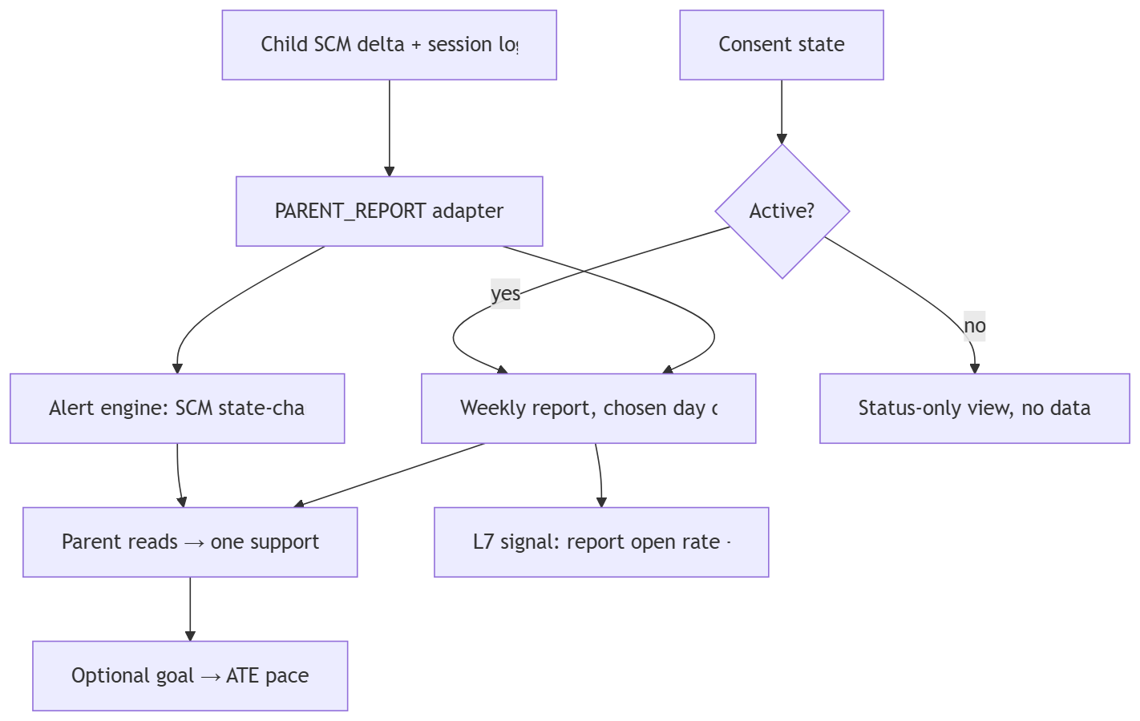

3. Boundary rules (DPDP)
Read-only over the connected child's SCM · no raw conversation logs · no comparisons
between children · parental consent enforced <18 · revocation cuts access within one
session · report answers "what does my child not understand," not time-spent vanity.

OKF
KF1 report delivered on chosen day, open rate >60% · KF2 alerts ≤5 min · KF3 zero
cross-child leakage in contract tests · KF4 revocation effective within 1 session ·
KF5 spend figures reconcile to billing records to the rupee.

